ASSIGNMENTS FOR JAVASCRIPT
CHAPTER: NO: 01
1. Write a script to greet your website visitor using JS alert
Box?
CODE:
alert("HANNAN AHMED JUTT \n Roll No: 360749 \n Batch: 9 \n Welcome to my website!");

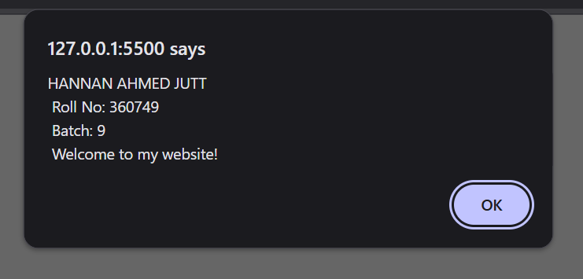
2. Write a script to display following message on your web
Page?
CODE:
alert("HANNAN AHMED JUTT \n Roll No: 360749 \n Batch: 9 \n Error! Please enter a valid password.");

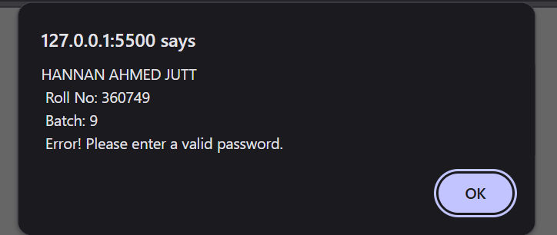

3. Write a script to display following message on your web
Page. (Hint: Use line break)
CODE:
alert("HANNAN AHMED JUTT \n Roll No: 360749 \n Batch: 9 \n Welcome to JS Land... \n Happy Coding!");

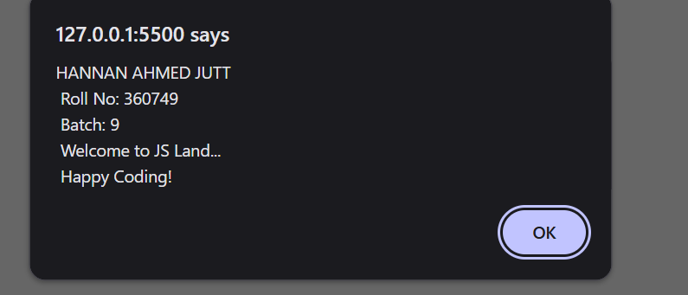
4. Write a script to display following messages in sequence?
CODE:
alert("HANNAN AHMED JUTT \n Roll No: 360749 \n Batch: 9 \n Welcome to JS Land...");
alert("HANNAN AHMED JUTT \n Roll No: 360749 \n Batch: 9 \n Happy Coding!");

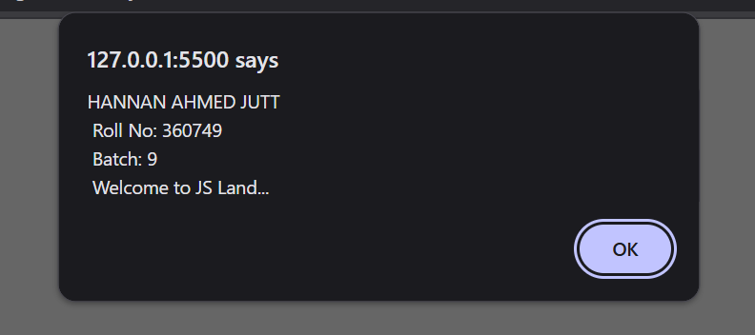
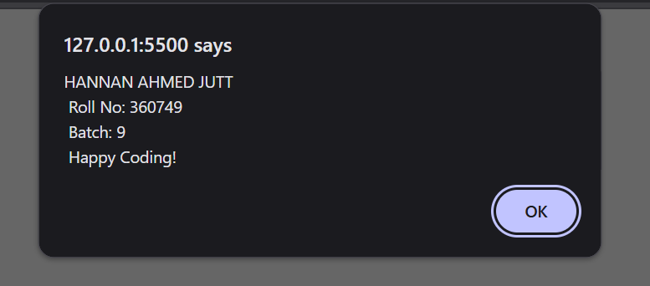

5. Generate the following message through browser’s
Developer console?
CODE:
alert("HANNAN AHMED JUTT \n Roll No: 360749 \n Batch: 9 \n Hello... I can run JS through my web browser's console");

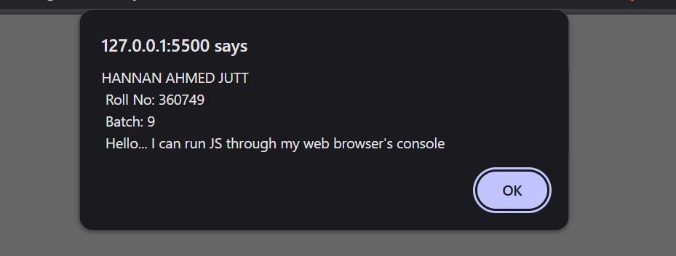
6. Make use of alerts in your new/existing HTML & CSS
Project?
CODE:
<button onclick="showAlert()">Click Me</button>

<!-- c. Script in Body (inside your page’s HTML) -->
<script >
function showAlert() {
alert("Hello! This is my project alert.");
}
</script>

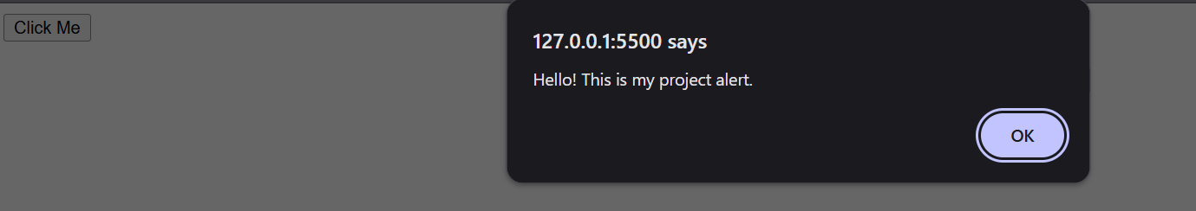
7. Practice placement of <script></script> element in
Following sections of your project in exercise 6:
a. Head
b. Body (before your page’s HTML)
c. Body (inside your page’s HTML)
d. Body (after your page’s HTML)
CODE A:
<head>
<meta charset="UTF-8">
<meta name="viewport" content="width=device-width, initial-scale=1.0">
<title>ASSIGNMENT'S JS</title>
<!-- a. Script in Head -->
<script>
alert("Script in Head");
</script>
</head>

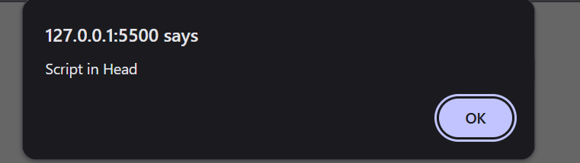
CODE B:
<body>
<!-- b. Script in Body (before your page’s HTML) -->
<script>
alert("Before HTML content");
</script>

</body>

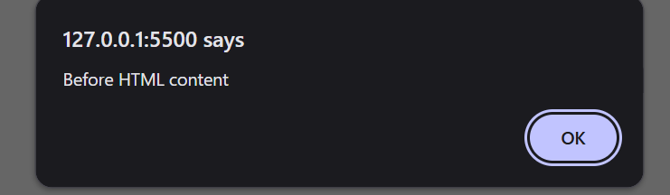
CODE C:
<body>

<!-- c. Script in Body (inside your page’s HTML) -->
<h1 onclick="myFunction()">Click this heading</h1>

<script>
function myFunction() {
alert("You clicked the heading!");
}
</script>
</body>

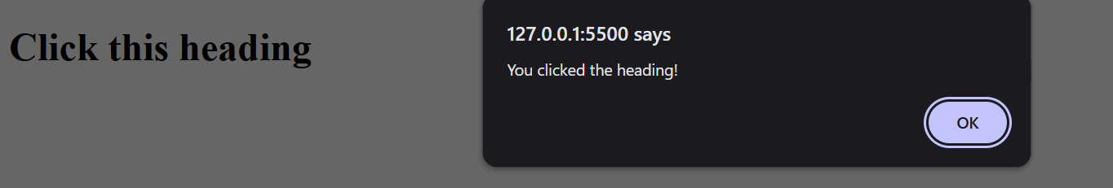
CODE D:
<body>

<!-- d. Script in Body (after your page’s HTML) -->
<script>
alert("After HTML loaded");
</script>
</body>

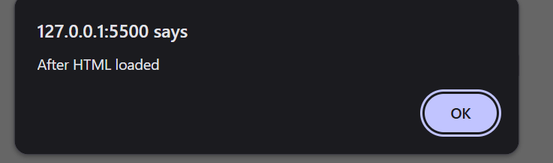

CHAPTER: NO: 02

1. Declare a variable called username.
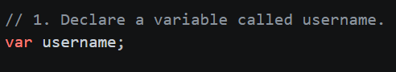
2. Declare a variable called myName & assign to it a string
That represents your Full Name.
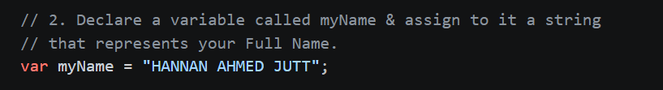
3. Write script to
a) Declare a JS variable, titled message.
b) Assign “Hello World” to variable message
c) Display the message in alert box.
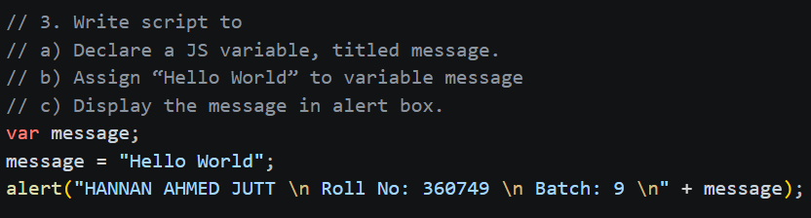
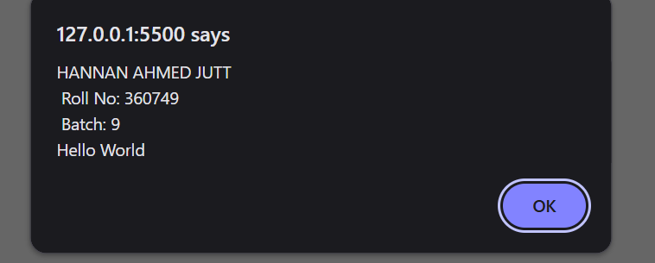
4. Write a script to save student’s bio data in JS variables and
Show the data in alert boxes.
CODE:
var studentName = "HANNAN AHMED JUTT";
var studentAge = 21;
var studentCourse = "Web & Mobile Hybrid Application Development";
alert("HANNAN AHMED JUTT \n Roll No: 360749 \n Batch: 9 \nStudent Name: " + studentName);
alert("HANNAN AHMED JUTT \n Roll No: 360749 \n Batch: 9 \nStudent Age: " + studentAge);
alert("HANNAN AHMED JUTT \n Roll No: 360749 \n Batch: 9 \nStudent Course: " + studentCourse);

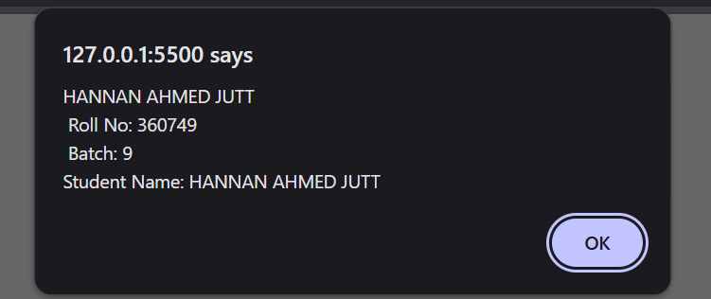
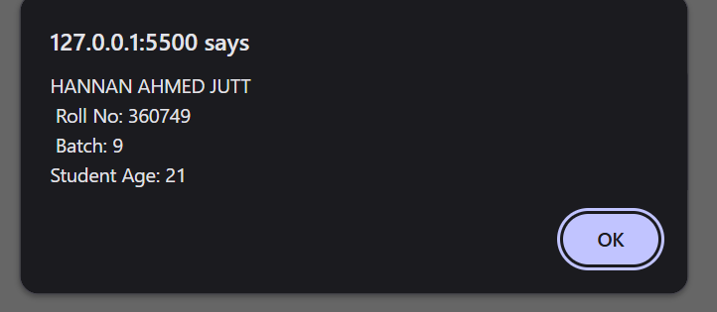
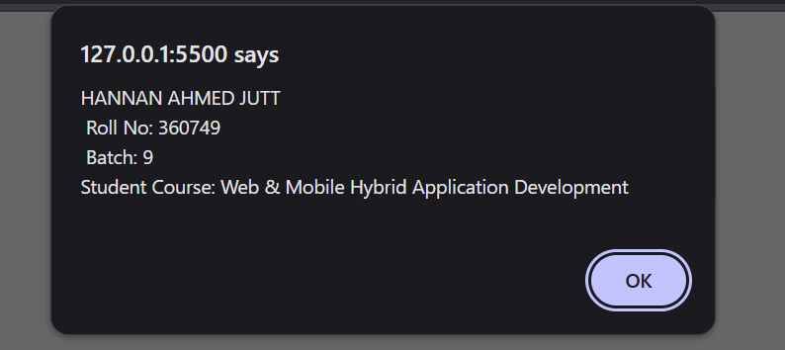

5. Write a script to display the following alert using one JS
Variable:
CODE:
var pizzaMessage = "PIZZA\nPIZZ\nPIZ\nPI\nP";
alert("HANNAN AHMED JUTT \n Roll No: 360749 \n Batch: 9 \n" + pizzaMessage);

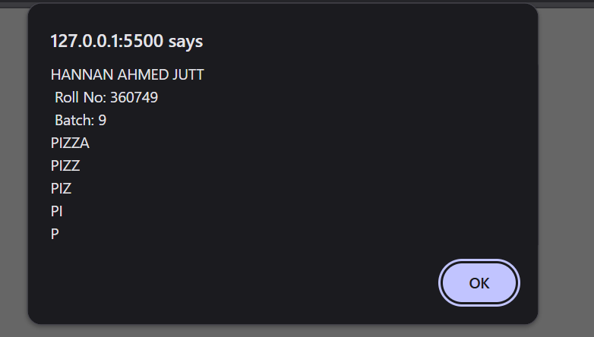

6. Declare a variable called email and assign to it a string that
Represents your Email Address (e.g. example@example.com).
Show the blow mentioned message in an alert box.(Hint: use
String concatenation)
CODE:
var email = "h3089467@gmail.com";
alert("HANNAN AHMED JUTT \n Roll No: 360749 \n Batch: 9 \nYour email address is: " + email);

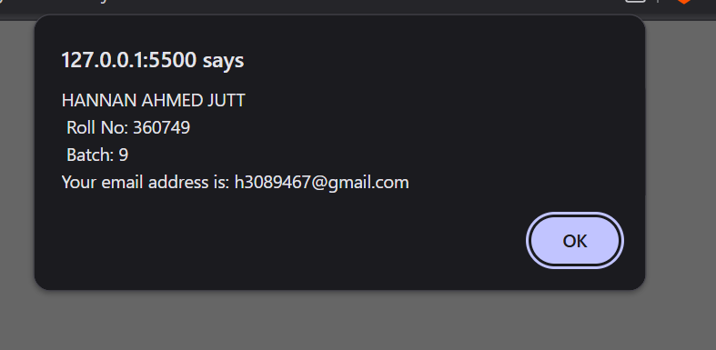
7. Declare a variable called book & give it the value “A
Smarter way to learn JavaScript”. Display the following
Message in an alert box:
CODE:
var book = "A smarter way to learn JavaScript";
alert("HANNAN AHMED JUTT \n Roll No: 360749 \n Batch: 9 \nI am trying to learn from the book " + book);

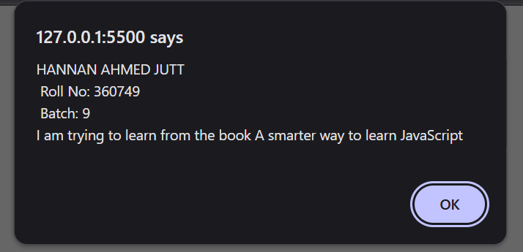
8. Write a script to display this in browser through JS
CODE:
document.write("Yah! I can write HTML content through JavaScript");

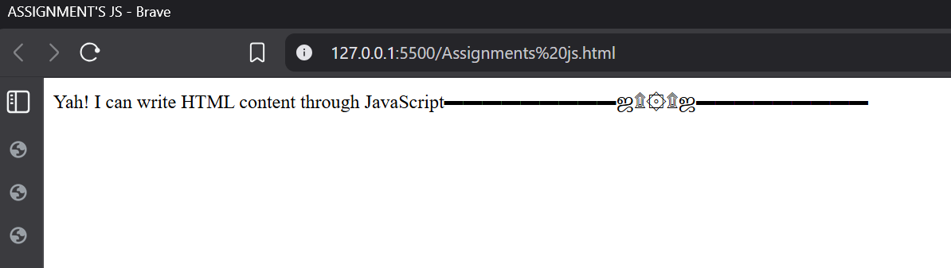
9. Store following string in a variable and show in alert and
Browser through JS
CODE:
var designMessage = "▬▬▬▬▬▬▬▬▬ஜ۩۞۩ஜ▬▬▬▬▬▬▬▬▬";
alert("HANNAN AHMED JUTT \n Roll No: 360749 \n Batch: 9 \n" + designMessage);
document.write(designMessage);

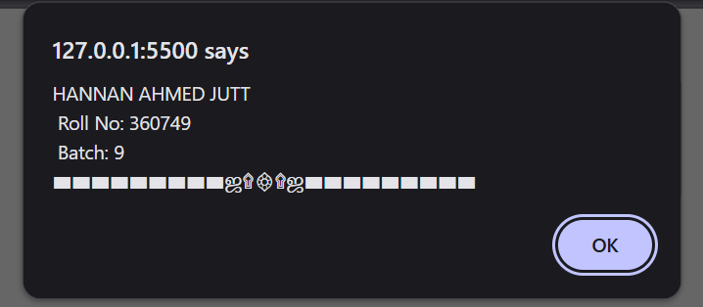
CHAPTER: NO: 03

1. Declare a variable called age & assign to it your age. Show
Your age in an alert box.
CODE:
var age = 21;
alert("HANNAN AHMED JUTT \n Roll No: 360749 \n Batch: 9 \nI am " + age + " years old");

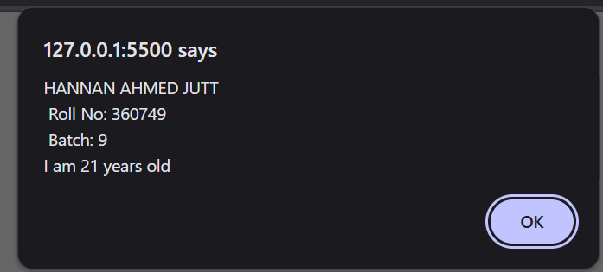
2. Declare & initialize a variable to keep track of how many
Times a visitor has visited a web page. Show his/her
Number of visits on your web page. For example: “You
Have visited this site N times”.
CODE:
var visitCount = 14;
alert("HANNAN AHMED JUTT \n Roll No: 360749 \n Batch: 9 \nYou have visited this site " + visitCount + " times");
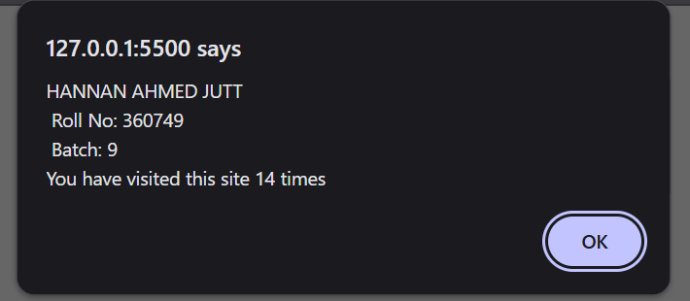
3. Declare a variable called birth Year & assign to it your
birth year. Show the following message in your browser:
CODE:
var birthYear = 2002;
document.write("HANNAN AHMED JUTT \n Roll No: 360749 \n Batch: 9 \nMy birth year is " + birthYear + "<br>Data type of my declared variable is number");

4. A visitor visits an online clothing store
Www.xyzClothing.com. Write a script to store in variables
The following information:
a. Visitor’s name
b. Product title
c. Quantity i.e. how many products a visitor wants to
Order
Show the following message in your browser: “John
Doe ordered 5 T-shirt(s) on XYZ Clothing store”.
CODE:
var visitorName = "HANNAN AHMED JUTT";
var productTitle = "T-shirt(s)";
var quantity = 5;
document.write("HANNAN AHMED JUTT \n Roll No: 360749 \n Batch: 9 \n" + visitorName + " ordered " + quantity + " " + productTitle + " on XYZ Clothing store");

CHAPTER: NO: 04

1. Declare 3 variables in one statement.
CODE:
var var1, var2, var3;

2. Declare 5 legal & 5 illegal variable names.
CODE:
var myName;
var age1;
var _total;
var $price;
var userData;

3. Display this in your browser
a) A heading stating “Rules for naming JS variables”
b) Variable names can only contain ______, ______,
______ and ______.
For example $my_1stVariable
c) Variables must begin with a ______, ______ or
_____. For example $name, _name or name
d) Variable names are case _________
e) Variable names should not be JS _________
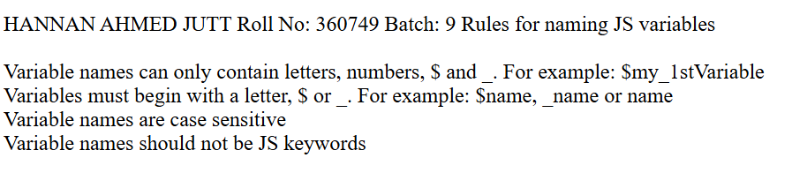
CHAPTER: NO: 05
1. Write a program that take two numbers & add them in a
New variable. Show the result in your browser.
2. Repeat task1 for subtraction, multiplication, division &
Modulus.
CODE:
var num1 = 5;
var num2 = 10;
var sum = num1 + num2;
document.write("HANNAN AHMED JUTT \n Roll No: 360749 \n Batch: 9 \nThe sum of " + num1 + " and " + num2 + " is: " + sum);

// 2. Repeat task1 for subtraction, multiplication, division & modulus.
var difference = num1 - num2;
document.write("<br>HANNAN AHMED JUTT \n Roll No: 360749 \n Batch: 9 \nThe difference of " + num1 + " and " + num2 + " is: " + difference);

var product = num1 * num2;
document.write("<br>HANNAN AHMED JUTT \n Roll No: 360749 \n Batch: 9 \nThe product of " + num1 + " and " + num2 + " is: " + product);

var quotient = num1 / num2;
document.write("<br>HANNAN AHMED JUTT \n Roll No: 360749 \n Batch: 9 \nThe quotient of " + num1 + " and " + num2 + " is: " + quotient);

var modulus = num1 % num2;
document.write("<br>HANNAN AHMED JUTT \n Roll No: 360749 \n Batch: 9 \nThe modulus of " + num1 + " and " + num2 + " is: " + modulus);

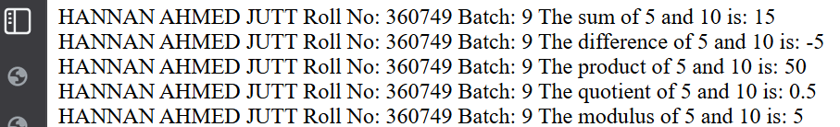
3. Do the following using JS Mathematic Expressions
a. Declare a variable.
b. Show the value of variable in your browser like “Value
After variable declaration is?”
c. Initialize the variable with some number.
d. Show the value of variable in your browser like “Initial
Value: 5”.
e. Increment the variable.
f. Show the value of variable in your browser like “Value
After increment is: 6”.
g. Add 7 to the variable.
h. Show the value of variable in your browser like “Value MATH EXPRESSIONS | JAVASCRIPT
After addition is: 13”.
i. Decrement the variable.
j. Show the value of variable in your browser like “Value
After decrement is: 12”.
k. Show the remainder after dividing the variable’s value
by 3.
l. Output: “The remainder is: 0”.
CODE:
var myVariable;
document.write("<br>HANNAN AHMED JUTT \n Roll No: 360749 \n Batch: 9 \nValue after variable declaration is: " + myVariable);

// c. Initialize the variable with some number.
myVariable = 5;
document.write("<br>Value after variable initialization is: " + myVariable);
// d. Increment the variable.
myVariable++;
document.write("<br>Value after increment is: " + myVariable);
// e. Add 7 to the variable.
myVariable += 7;
document.write("<br>Value after adding 7 is: " + myVariable);
// f. Decrement the variable.
myVariable--;
document.write("<br>Value after decrement is: " + myVariable);
// g. Show the remainder after dividing the variable’s value by 3.
var remainder = myVariable % 3;
document.write("<br>The remainder after dividing the variable's value by 3 is: " + remainder);

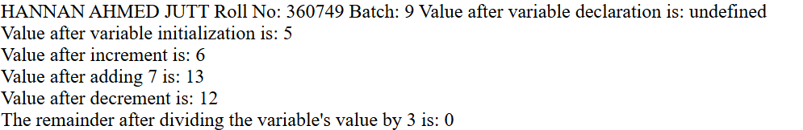

4. Cost of one movie ticket is 600 PKR. Write a script to
Store
Ticket price in a variable & calculate the cost of buying 5
Tickets
To a movie. Example output:
CODE:
var ticketPrice = 600;
var numberOfTickets = 5;
var totalCost = ticketPrice * numberOfTickets;
document.write("<br>Total cost to buy " + numberOfTickets + " tickets to a movie is " + totalCost + " PKR");

5. Write a script to display multiplication table of any
number in your browser. E.g
CODE:
var number = 5;
document.write("<br>Multiplication Table of " + number + "<br>");
for (var i = 1; i <= 10; i++) {
document.write(number + " x " + i + " = " + (number * i) + "<br>");
}

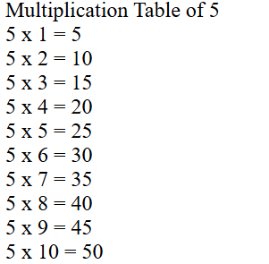

6. The Temperature Converter: It’s hot out! Let’s make a
Converter based on the steps here.
a. Store a Celsius temperature into a variable.
b. Convert it to Fahrenheit & output “NN
O
C is NN
o
F”.
c. Now store a Fahrenheit temperature into a variable.
d. Convert it to Celsius & output “NN
o
F is NN
o
C”.
CODE:
var celsiusTemp = 30;
var fahrenheitTemp = (celsiusTemp * 9/5) + 32;
document.write("<br>" + celsiusTemp + "°C is " + fahrenheitTemp + "°F");
// c. Now store a Fahrenheit temperature into a variable.
var fahrenheitTemp2 = 86;
// d. Convert it to Celsius & output “NNoF is NNoC”.
var celsiusTemp2 = (fahrenheitTemp2 - 32) * 5/9;
document.write("<br>" + fahrenheitTemp2 + "°F is " + celsiusTemp2 + "°C");

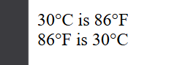
7. Write a program to implement checkout process of a
Shopping cart system for an e-commerce website. Store
The following in variables
a. Price of item 1
b. Price of item 2
c. Ordered quantity of item 1
d. Ordered Quantity of item 2
e. Shipping charges
Compute the total cost & show the receipt in your browser.
CODE:
var priceItem1 = 1000;
var priceItem2 = 500;
var quantityItem1 = 2;
var quantityItem2 = 3;
var shippingCharges = 200;
var totalCost = (priceItem1 * quantityItem1) + (priceItem2 * quantityItem2) + shippingCharges;
document.write("<br><h2>Shopping Cart Receipt</h2>");
document.write("Price of item 1: " + priceItem1 + " PKR<br>");
document.write("Quantity of item 1: " + quantityItem1 + "<br>");
document.write("Price of item 2: " + priceItem2 + " PKR<br>");
document.write("Quantity of item 2: " + quantityItem2 + "<br>");
document.write("Shipping Charges: " + shippingCharges + " PKR<br>");
document.write("<h3>Total Cost: " + totalCost + " PKR</h3>");

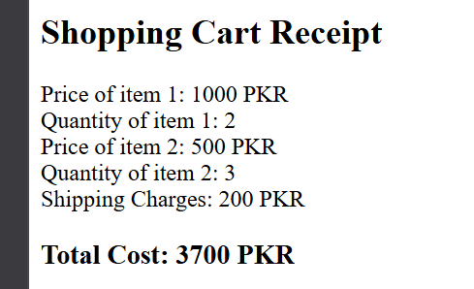
8. Store total marks & marks obtained by a student in 2
variables. Compute the percentage & show the result in
your browser
CODE:
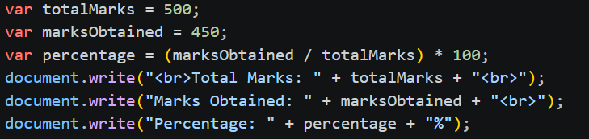
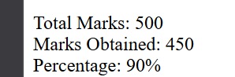
9. Assume we have 10 US dollars & 25 Saudi Riyals. Write a
script to convert the total currency to Pakistani Rupees.
Perform all calculations in a single expression.
(Exchange rates : 1 US Dollar = 104.80 Pakistani Rupee
and 1 Saudi Riyal = 28 Pakistani Rupee)
CODE:
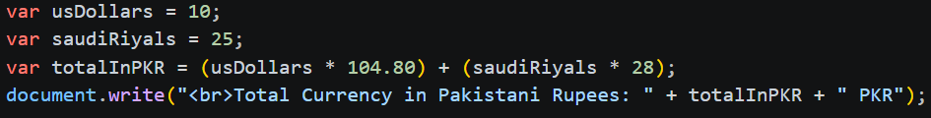
10. Write a program to initialize a variable with some
Number and do arithmetic in following sequence:
a. Add 5
b. Multiply by 10
c. Divide the result by 2
Perform all calculations in a single expression
CODE:
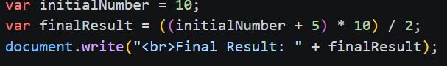
11. The Age Calculator: Forgot how old someone is?
Calculate it!
a. Store the current year in a variable.
b. Store their birth year in a variable.
c. Calculate their 2 possible ages based on the stored
Values.
Output them to the screen like so: “They are either NN or NN
Years old”.
CODE:
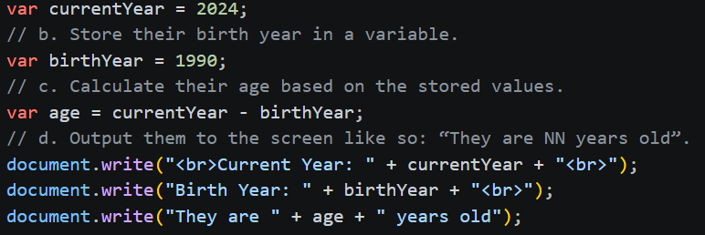
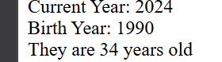
12. The Geometrize: Calculate properties of a circle.
a. Store a radius into a variable.
b. Calculate the circumference based on the radius, and
Output “The circumference is NN”.
(Hint: Circumference of a circle = 2 π r , π = 3.142)
Calculate the area based on the radius, and output “The
area is NN”. (Hint : Area of a circle = π r
2
, π = 3.142)
CODE:
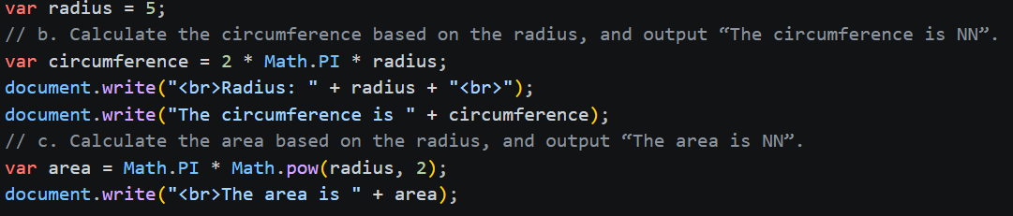
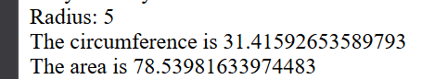
13. The Lifetime Supply Calculator: Ever wonder how
Much a “lifetime supply” of your favorite snack is?
Wonder no more.
a. Store your favorite snack into a variable
b. Store your current age into a variable.
c. Store a maximum age into a variable.
d. Store an estimated amount per day (as a number).
e. Calculate how many would you eat total for the rest of
Your life.
Output the result to the screen like so: “You will need
NNNN to last you until the ripe old age of NN”.
CODE:
